**How to Associate and Disassociate an Elastic IP to an EC2 Instance**

1. Go to the [AWS Console](http://www.newvem.com/cloudpedia/amazon-aws-console/) and select the EC2 Service. It will list the AWS dashboard. It lists the current running instances, snapshots and elastic IPs. Click on the “Running Instance” link or the “Instances” link in the left navigation menu.

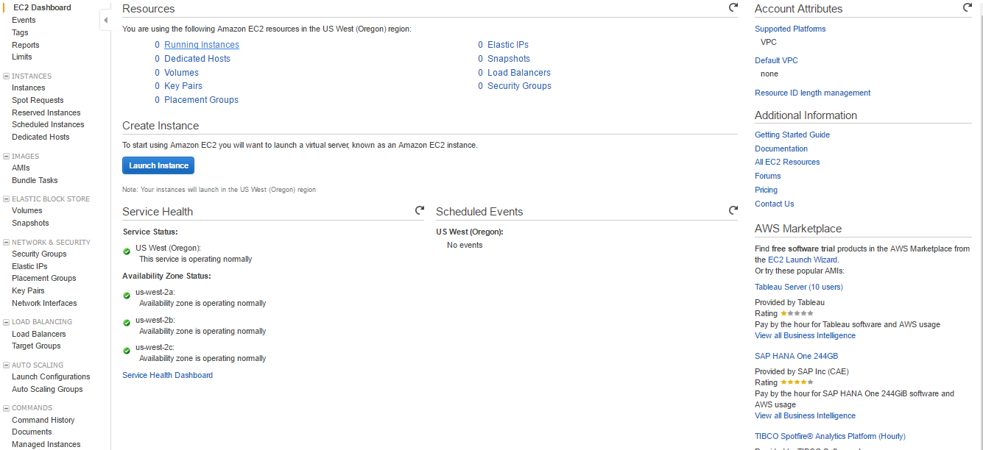

1. The [EC2 Instances](https://www.newvem.com/cloudpedia/types-of-amazon-aws-ec2-instances/) dashboard displays all the instances of that region. When the instance is launched, AWS assigns a public IP to the instance.

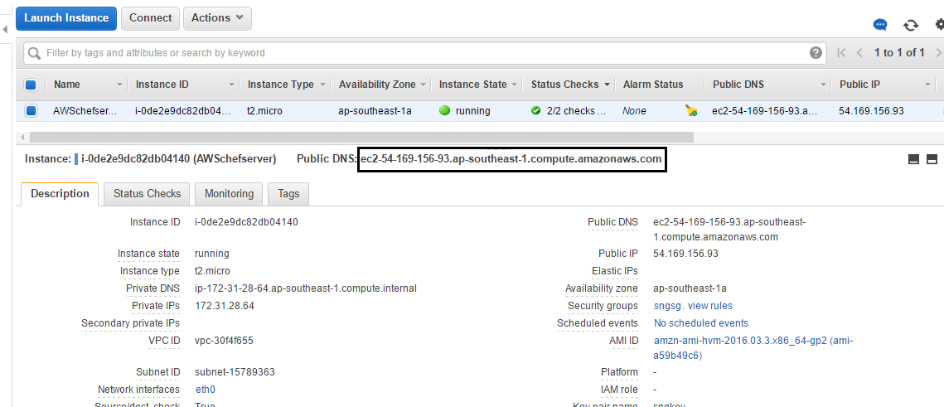

1. Go to Elastic IP dashboard by clicking on the “Elastic IP” in step#1. It lists all the Elastic IPs of that region. Select an elastic IP to be assigned to the instance and click on the “Associate Address” button.

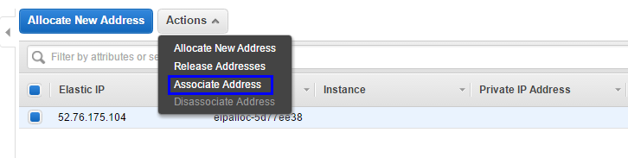

1. It asks for the instance which will be associated with this IP. Select the instance from the list and click on “Yes, Associate”.

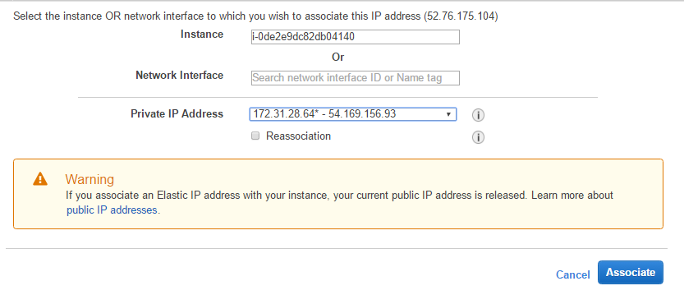

1. It will associate the elastic IP to that instance. Go to Instance dashboard and select the instance. The IP of the instance is updated to the elastic IP.

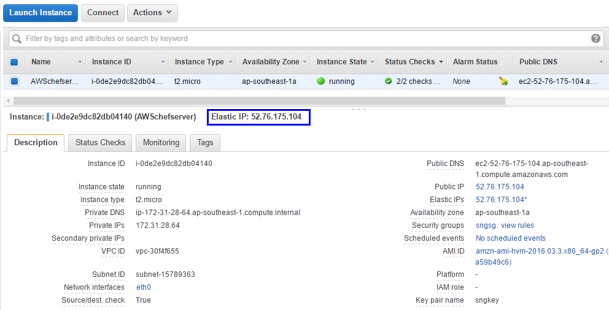

1. To disassociate the instance, Go to Elastic IP dashboard by clicking on the “Elastic IP” in step#1. It lists all the Elastic IPs of that region. Select an elastic IP to be the instance and click on “Disassociate Address” from the Actions menu.

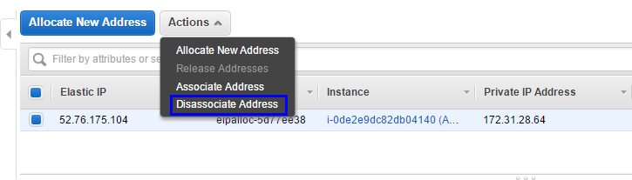

1. AWS will ask for a confirmation before disassociating the address. Click on “Yes, Disassociate”.

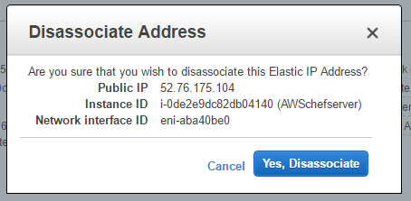

1. The elastic IP address associated with the instance will be disassociated. The above mentioned IP can be reassigned to any other instance. If the IP address is unassigned, it will cost the user. Release the IP address if the user does not require it.

The figure given below demonstrates the instance with the new public IP after the elastic IP has been disassociated.

